

Integrated State of Health
Monitoring Software

Introduction
The healthQueue Integrated State of Health Monitoring software was developed in conjunction with good practices and research from all over the world.
healthQueue, if implemented as designed, will initiate positive change in the way Integrated Health is performed in any business, and facilitate the adoption of “good practice” as well as standardisation across health services.
healthQueue integrates data in a logical and useful manner, i.e. mental health, primary health, occupation health, health and safety, human resources, inventory and workflow, to mention the main groupings. Value is added in both the analysis of information and statistics, as well as the identification of issues and exception management. Workflow, a notification board, emailing of information and scheduling of tasks improve the capability of communicating issues across the organisation.
Communication on all levels is enhanced via the integrated diary and task scheduler, which couples tightly into MS Outlook®. Emails are also automatically generated by the system where applicable, or manually controlled by the system user.
The program is extremely intuitive and easy to use and requires relatively little training. Comprehensive user manuals have however been developed for each module. These can be either printed or retrieved from the integrated document management system.
healthQueue can be used either be used as stand-alone software (i.e. selected modules running on one PC) or in an environment where more than one user can access the system simultaneously, based on individual system privileges and levels of access. A high level of security ensures confidentiality of data. Should the need arise to share any results, data can be exported into MS Excel®.

Good reasons to use the healthQueue integrated solution
Get value on your data investment
If your organization has a well-oiled clinic, you automatically have a significant investment in data - data that contains critical information about every aspect of your employees. Today more than ever, you need to get the best return on the data you have collected.
The analytics combines information on what has happened in the past, what is happening now, and what's likely to happen in the future to give you a complete picture of your employee.
Identify the hidden meaning in your data
The analytics helps you maximize the understanding gained from your data. It enables you to uncover hidden patterns, trends and relationships, and transform this information into action.
Predict, rather than being reactive
By leveraging sophisticated statistical and modelling techniques, you can anticipate future events and be proactive, rather than reactive by using the data you already own to help you.
Deliver intelligent reports in real time
Your business is dynamic. With predictive analytics, you can automatically deploy results to staff and the organisation as changes occur, helping to guide employee interactions and decision-making.
Empower data-driven decision making
Better processes help people throughout your organization make better decisions every day. Predictive analytics enables your organization to automate the flow of information to match your clinical practices and deliver the insights gained through this technology to staff that can apply them in their daily work.
Build customer intimacy
When you know each of your employees intimately-including what they think, say, and do-you can build stronger relationships with them. healthQueue gives you a complete view of your employees, and enables you to capture and maximize the value of each and every interaction.
Discover unexpected opportunities
Your department can use healthQueue to respond with greater speed and certainty to emerging challenges and opportunities, helping you to keep pace in a constantly changing business environment.
Guarantee your department's efficiency
healthQueue can drive improved performance to make your department run more efficiently.
Use ONE system for all your data
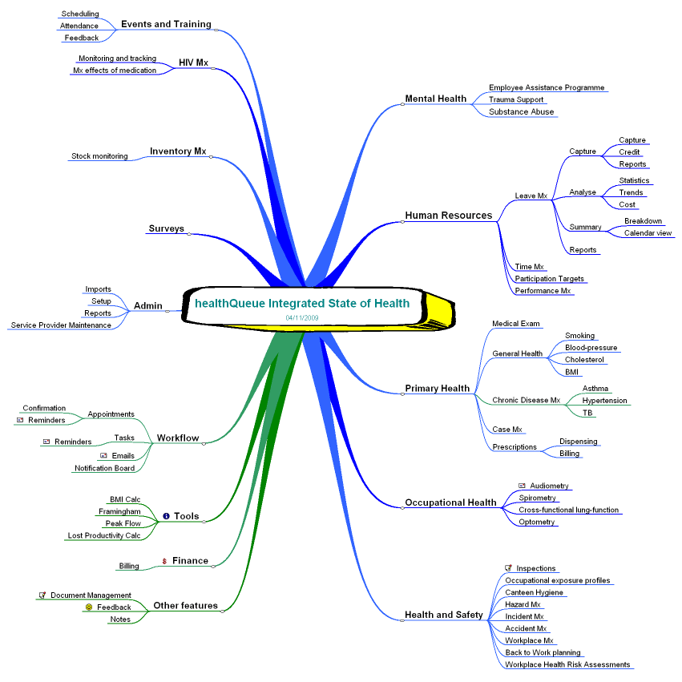
The employee is treated by the system as a member of a queue, i.e. s/he is registered as a case into the electronic queue, and assigned to one or more services within the clinic. These include the following:

Mental Health
EAP (Employee Assistance Programme): Psycho-social support is the pivot around which everything revolves, as it addresses the mental aspects of the employee, and can have an impact on all the other components of health. This module addresses EAP and counselling provision
Substance abuse monitoring: An employee can be screened for substance abuse, and a notice is sent to the EAP department for further action
Trauma Support Refer employees to available and registered external support for trauma

Human Resources
Leave capturing: Manual capturing of leave records into the system. This data can also be imported into the system from an Excel spreadsheet that could be the result of a data export from an existing HR system
Leave analysis: Leave records are analysed in detail for trends, e.g. Monday / Friday syndrome, the Bradford Score, effects of disease management, etc. Annual departmental comparisons can also be performed for absenteeism management, and determining the cost of illness and absenteeism.
Time management: Electronic timekeeping records (imported from Time-keeping system if available) are analysed for trends, e.g. late arrival, early exits.
Performance management: The performance of employees is measured against baselines, and compared to measurements done after interventions have taken place

Primary Health Management
Medical examinations
- pre-employment-,
- scheduled- and
- exit-medicals
- These assessments include screening for
  - Smoking
  - Blood pressure
  - Cholesterol
  - Vision
  - BMI, etc
Medication prescription
This will notify the pharmacy (if available) to dispense certain medication.
Appointment scheduling is handled by the integrated appointment and task management system
Dispensing of medication: Dispense items, orders based on minimum stock levels
  - Print medication labels: Printing of labels for medication issued (graphic)
Case management: Monitoring of cases that are off-site, i.e. in hospital or at home

Occupational Healthcare
Spirometry: Monitoring of respiration assessments. This also includes the cross-functional testing to determine the origin of respiratory problems such as Asthma
Audiometry: Monitoring of hearing assessments
Optometry: Capturing of eye-test results

Health and safety
This is normally handled in a package specific to an industry. However, notifications for action are handled in healthQueue
Inspections: Inspections of workplaces are held on a regular basis to determine compliance. The results of the inspections are logged in the system.
Hazard Management
Incident logging (near misses): Logging of small incidents like slipping on the floor in the corridor, which could lead to a later claim for Accident Compensation
Management of Accidents / Injury on Duty (IOD): Manage an injury at the workplace
  - Medical management
  - Assign sick leave to the IOD category
  - Record injuries graphically onto diagrams of the body, and display either a specific case or all injuries over time
  - Import ACC data, match to employee and monitor ACC claims
Assessments:
  - Occupational exposure profiles: Every job should have certain physical and mental baselines based on occupational surroundings and risk, which could differ from workplace to workplace within an organisation. These criteria could be taken into consideration when doing EAP or medical examinations of an employee
  - Canteen Hygiene inspections: Companies with canteens have to comply with certain regulations. This module enables effective monitoring based on a list of grouped specifications
  - Workplace Health Risk Assessment: The individual work areas can be categorised according to predefined criteria such as Hazard ratings, e.g. excessive noise
Back to Work plans: Setting up the back-to-work plan for an employee that has been away due to illness or any other health-related reason.

Chronic disease management
Asthma
Hypertension (Framingham model)
Tuberculosis
Others

HIV management
This can be used as a stand-alone module, especially in countries where the pandemic is enormous. Comprehensive data collection is done in this module, which is configurable depending on the types of medications issued.
Monitoring of Voluntary Test and Counselling (against predefined targets), accompanied by results and analysis
Monitoring and tracking of intervention such as peer educator programs, education programs, awareness campaigns etc via the Events and Training module
Monitoring of HIV cases with regards to CD4 counts, Viral Load, Weight, Absenteeism rates, follow up visits etc
Tracking of impact of ARV’s on CD4 and Viral load

Events and training: Events and training can be scheduled for employees. Email reminders are sent to those participants that have email, and to the respective managers. Feedback of the training / event can be captured

Inventory management: Complete stock control system (stand-alone) that integrates into the healthQueue database

Participation targets of the health team: The team can define the number of cases that will be handled per service. The system compares the actual cases against the ‘budget’ values

Billing module: Clients (for example contractors on a site) can be billed for the services provided to them if the company wishes to do so.

Service Provider Maintenance: Up keeping of data pertaining to service providers such as external companies, hospitals, trauma centres, etc

Survey module: Questions can be created by category, and the responses can be defined per question. The results of the survey questionnaire can then be captured into the system, and reports created

A feedback module for clients of the wellness programme
Once the employee has been treated, s/he is released from the queue. At this stage, the system generates an attendance email to the supervisor (except if the consultation was of a confidential nature, such as EAP or HIV treatment).

Additional features
Single client view: History of a client / employee can be drawn based on the access rights that the user may have. For example, if the client has a history of HIV treatment, EAP as well as Medical checkups, a practitioner that has limited access to the Medical Examination module can only see the medical records, while a user that has access to all modules can see all the client records.

A comprehensive electronic document management system (DMS): Documents can be attached to the various components, and be retrieved either by individual and/or by component. This also includes rule-based email attachment management, where Outlook can be scanned on a predefined interval and attachments are extracted and saved to a location.

Client Queue handling (workflow): Clients are checked into the system, and allocated to the respective treatment facility. Once the treatment has been concluded, the client is released from the system, resulting in a series of activities such as manager notification, etc.

Reports per component: Various reports are available, both pre-defined (Crystal Reports) as well as into Excel from result grids, such as monthly usage of the facilities, equity spread, etc

Inter-service appointment scheduling and tasking (Workflow): Appointments can be scheduled for an employee by manually selecting the target service, or automatically by the system. The same applies for the creation of tasks, which in turn can be converted into appointments by the targeted person. The appointments and tasks can be integrated into Microsoft Outlook®, based on user preference.

Electronic reminders: Appointment reminders are sent to the employees as well as the manager as soon as they are created, and again one day before the appointment is due

Notification to managers on activities: Employees are ‘queued’ into the system at arrival at the health station. Once they have completed the visit, the manager is informed of the visit, except if the Health Station should keep the visit confidential.

Comparisons of examinations done: History is analysed and deviations are indicated by means of colouring

Comprehensive electronic communication: This includes automated emails to various entities as well as a ticker-system (on-screen notices, instant and scheduled)

Data imports: Data can either be imported in batches or by capturing the data manually. Data is imported from preformatted Excel spreadsheets that are populated by the organisation’s HR system.

Data exports: Data displayed on screen from the majority of modules can be exported to Excel for selective manipulation and reporting

Bulk SMS: SMS’s can be grouped for predefined recipients, and bulk packaged

Good-practice integrated tools such as
❖ BMI Calculator
❖ Coronary Heart Disease Risk Prediction
❖ Peak Flow
❖ Lost Productivity

A lot of effort has gone into the logical segregation of the above-mentioned modules, to enable confidentiality between the components. This means that the person doing audiometry will not necessarily have the privileges to see data pertaining to EAP, although tasks and appointments can be made across the boundaries.
During the implementation phase, most reference values are defined and imported into the system, therefore minimising customisation at a later stage. System parameters are easily captured by the business system administrator (BSA), who also defines the organisational structure during the setup.

